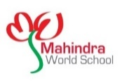

MAHINDRA WORLD SCHOOL
NeverSkip – 2023-2024
Dear Parent,
To promptly update parents on school activities, the Management has decided to send school messages to parents through Email and SMS. To facilitate this, we will use the services of Yokibu.com, a website for schools and parents. By signing this form, you agree to be registered on Yokibu.com and to receive messages relevant to your child from Yokibu.com
Kindly fill in the following details:-
Name of the Student: | First Name:
 | Last Name
Admn. No:
Gender:
Class and Section:
Date of Birth (DOB):
Father’s Name:
Father’s Mobile Number:
Father’s E-mail Id:
Mother’s Name:
Mother’s Name:
Mother’s Mobile Number:
Mother’s E-mail Id:
Signature of Father or Mother:

